**Lesson 12**

**Objectives**

* Entity Relationship Model (E-R Model/E-R Diagram)
  + Entity
    - Strong Entity
    - Weak Entity
  + Attributes
    - Simple vs Composite
    - Single vs Multivalued
    - Stored vs Derived
    - Optional vs Required
  + Identifier
  + Primary Key
  + Candidate Key
  + Relationship
  + Degree of Relationship
    - Unary
    - Binary
    - Ternary
    - Quaternary

**Entity Relationship Model (E-R Model/E-R Diagram)**

A logical representation of the data for an organization or for a business area.

Graphical representation that shows the relationship between entities of database.

The Entity–Relationship model has emerged as one of the main techniques for database design and forms the basis for the database design methodology used in this course.

**Entity**

A person, place, event, concept, or object in the user environment about which organization whishes to maintain data.

**Entity Type**

Group of objects with same properties, identified by enterprise as having an independent existence**.**

**Example**

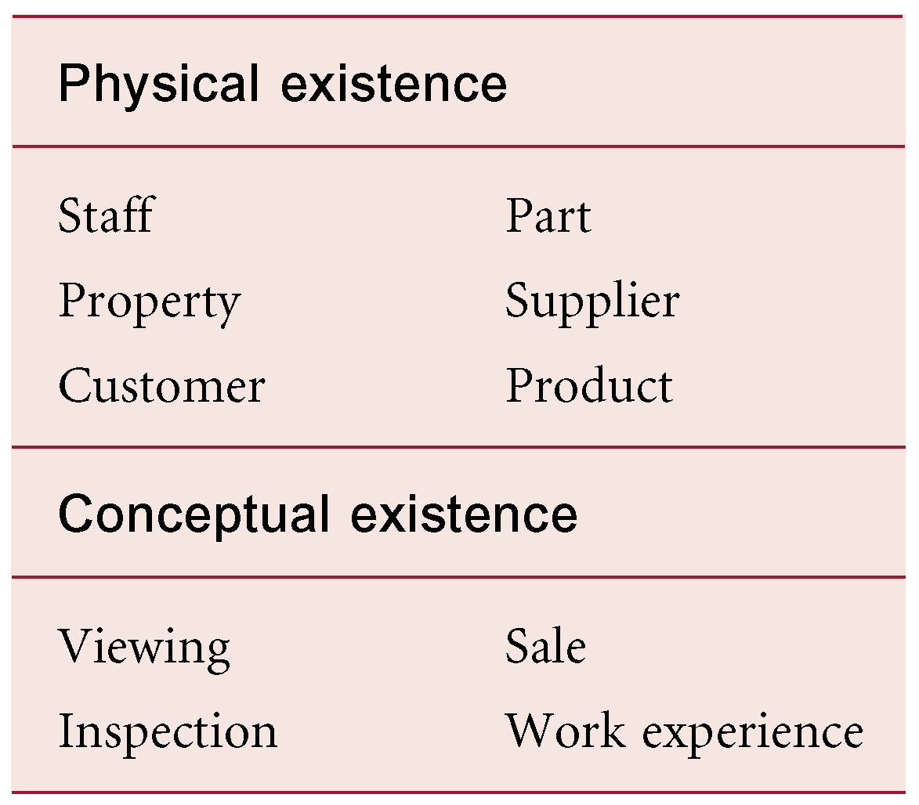

**Entity Notation:**

Entity is denoted by a rectangle by writing the name of an entity inside the rectangle.

Example:

Sale

Staff

**Entity Occurrence**

Uniquely identifiable object of an entity type.

**Entity Instance**

A single occurrence of an entity type.

**Strong Entity**

An entity that exists independently of other entities.

**Example**

Book, Course

**Weak Entity**

An entity whose existence depends on other entities.

**Notation**

Weak entity is denoted by double rectangle writing the name inside.

Line

Rectangle

**What should an Entity be?**

* An object that will have many instances in the database
* An object that will be composed of multiple attributes
* An object that we are trying to model

**What should an Entity not be?**

* A user of the database system
* An output of the database system (e.g. a report)

**Attribute**

A property or characteristic of an entity type that is of interest to the organization.

**Example:**

A student may have attributes; student_id, name, age, cgpa, etc.

**Notation:**

Attributes are shown in Oval in E-R model. Ovals are attached with Entity as given below

Student

**Attribute Domain**

Set of allowable values for one or more attributes.

Example: Domain of name attribute will be alphabets not numbers.

**Characteristics (Classification) of Attributes**

Attributes have following characteristics

* Required versus Optional Attributes
* Simple versus Composite Attribute
* Single-Valued versus Multivalued Attribute
* Stored versus Derived Attributes
* Identifier Attributes

**Required versus Optional Attributes**

An attribute that must have value for an entity instance is called **required** attribute. For example instance of student must have a name, id. So name and id will have required characteristics.

An attribute that may not have value for an entity instance is called **optional** attribute. For example instance of student may have a contact. So contact will have optional characteristics.

**Simple versus Composite Attribute**

Attribute composed of a single component with an independent existence is referred as **simple** attribute.

Attribute composed of multiple components, each with an independent existence is referred as **composite** attribute.

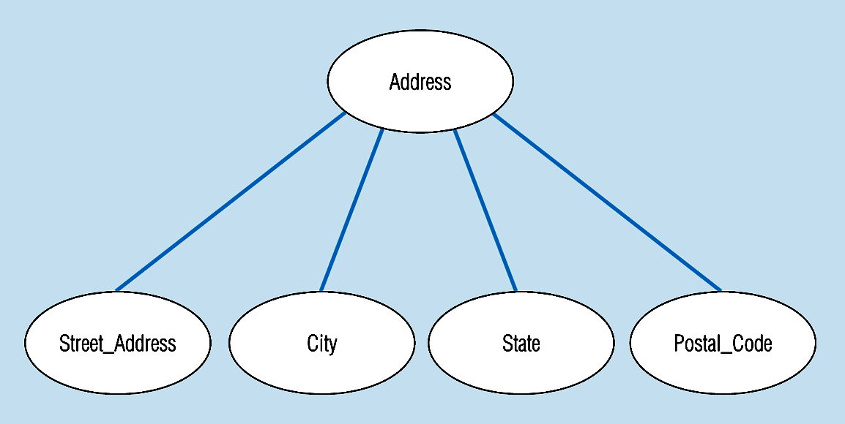

Address is composite while city, state, street_address, and postal_code are simple attributes.

**Single-Valued versus Multivalued Attribute**

Attribute that holds a single value for each occurrence of an entity type is referred as single valued.

Attribute that holds multiple values for each occurrence of an entity type is referred as multivalued.

In the given example below: Skill is multivalued attribute and denoted by double oval while remaining attributes are single valued.

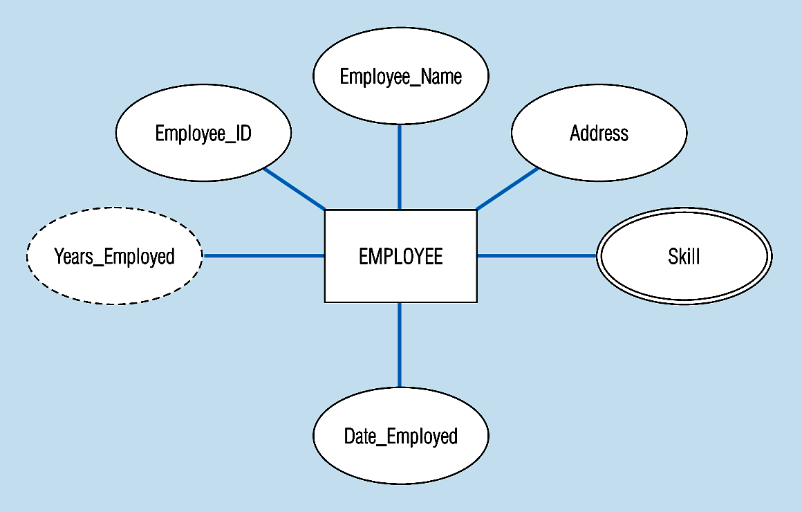

**Stored versus Derived Attributes**

Attribute that represents a value that is derivable from value of a related attribute, or set of attributes, not necessarily in the same entity type is referred as derived attribute.

In the above example years_Employed is a derived because it is derived by Date_Employed and the remaining attributes are stored attributes.

**Identifier**

An attribute (or combination of attributes) that uniquely identifies individual instances of an entity type is referred as identifier. In abode example Employee_ID will be an identifier due to having ability to uniquely identifying the individual instance. Name cannot be an identifier because there is a chance of two employees with same name.

**Candidate Key**

Minimal set of attributes that uniquely identifies each occurrence of an entity type.

**Primary Key**

Candidate key selected to uniquely identify each occurrence of an entity type**.**

**Composite Key**

A primary key that consists of two or more attributes.

**Relationship**

A meaningful associations among entity types

**Relationship occurrence**

Uniquely identifiable association, which includes one occurrence from each participating entity type.

**Degree of a Relationship**

Number of participating entities in relationship is referred as degree of relationship.

**Classification of Relationship on the base of Degree**

* Unary Relationship
* Binary Relationship
* Ternary Relationship
* Quaternary Relationship

**Unary Relationship**

A relationship between the instances of a single entity type is referred as unary relationship.

One entity related to another of the same entity type

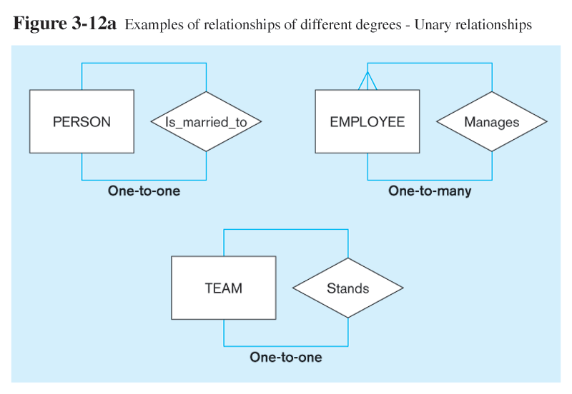

**Binary Relationship**

A relationship between instances of two entity types.

Entities of two different types related to each other

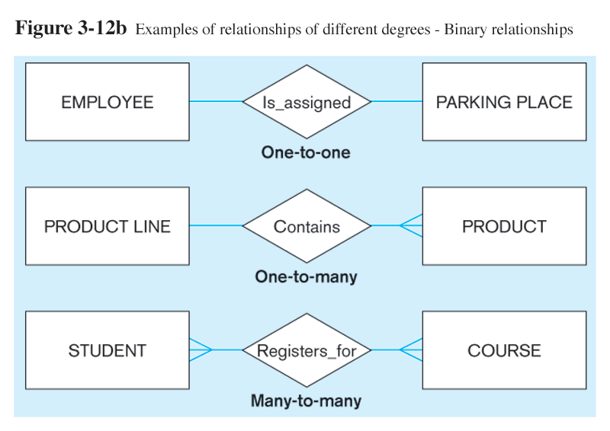

**Ternary Relationship**

A simultaneous relationship among the instances of three entity types

Entities of three different types related to each other

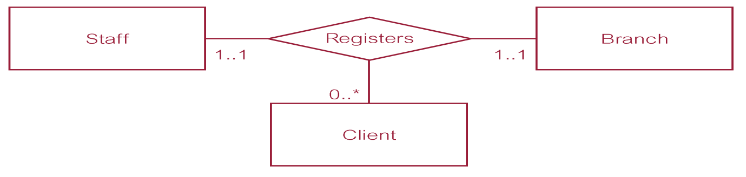

**Quaternary Relationship**

A simultaneous relationship among the instances of four entity types

Entities of four different types related to each other.

Agent arranges bid on behalf of a buyer supported by a financial institution.

Agent

Financial Institution

Arranges

Buyer

Bid